Chapter 19, Solution 54.

For the y parameters
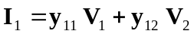 (1)
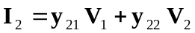 (2)

From (2),
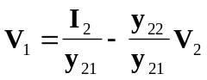
or 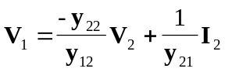 (3)

Substituting (3) into (1) gives
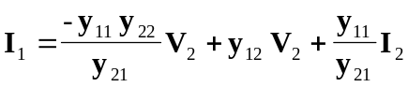
or 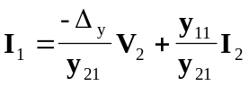 (4)

Comparing (3) and (4) with the following equations
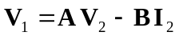
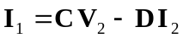

clearly shows that
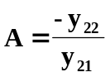, 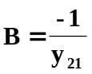, 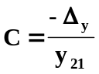, 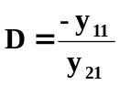
as required.

